FeyNN Labs: Project 3

## Recommendation system for e-commerce businesses

**Contributors: Aditi Rastogi , Anshu Mishra, Attada Ramprasad ,Ayush Kumar and Madan S**

**GitHub Link:** <https://github.com/Pratyush-exe/FeyNN_Labs_proj_2>

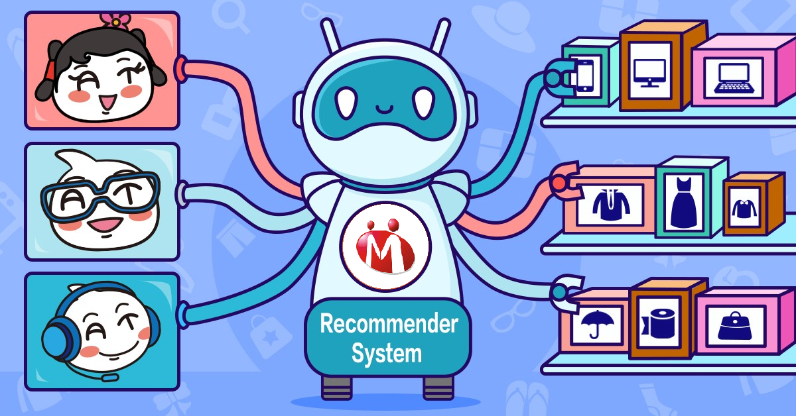

# Problem Statement

Problem Statement: Developing an Effective E-commerce Recommendation System

In the rapidly evolving e-commerce sector, businesses face challenges in engaging customers and boosting sales. Traditional recommendation systems often lack personalization and struggle with new businesses lacking user history. The problem is to create an innovative recommendation system that:

* Addresses the 'Cold Start' issue for new customers by offering tailored recommendations.
* Enhances personalization based on user behaviors and preferences.
* Improves customer retention through continuously updated suggestions.
* Overcomes data scarcity by generating insightful recommendations with limited data.
* Directly impacts revenue growth by influencing purchase decisions.

This system must leverage advanced data analysis and AI techniques to predict user preferences accurately and provide actionable recommendations, fostering user engagement and sales expansion for e-commerce businesses.

# Data Collection

Data Collection: Utilizing Kaggle Datasets

For our recommendation system project, we have sourced valuable datasets from Kaggle, a trusted platform for open data. Specifically, we have selected two datasets:

Dataset Link: [Amazon Product Review Dataset](https://www.kaggle.com/skillsmuggler/amazon-ratings)

* This dataset provides insights into user interactions, reviews, and ratings for various products on Amazon.
* Size: Millions of records capturing user IDs, product IDs, ratings, and timestamps.
* Relevance: Reflects real-world user behaviors and preferences, serving as a robust foundation for our recommendation system.

Dataset Link: [Home Depot Product Descriptions](https://www.kaggle.com/c/home-depot-product-search-relevance/data)

* This dataset contains product descriptions from Home Depot, enabling us to explore textual clustering analysis for recommendation.
* Size: Comprehensive product descriptions to enhance our recommendation system's capabilities.

By leveraging these Kaggle datasets, we ensure that our recommendation system is based on accurate, diverse, and real-world data. Ethical data usage and privacy considerations are of utmost importance, and we have taken measures to adhere to guidelines and maintain data security throughout our project. With these datasets, we are equipped to design, analyze, and develop a powerful recommendation system tailored to the needs of e-commerce businesses.

**Data Preprocessing**

# In the development of our E-commerce Recommendation System, meticulous data processing played a pivotal role. We initiated the process by acquiring two crucial datasets from Kaggle: the Amazon Product Ratings and Home Depot Product Descriptions. To ensure data quality and consistency, a comprehensive cleaning and preprocessing phase was undertaken. Within the Amazon dataset, missing values were meticulously handled, user and product IDs were optimized, and data was aggregated to quantify product popularity. Timestamps were converted for meaningful insights. The Home Depot dataset underwent similar scrutiny, with missing entries removed and text preprocessed for efficient clustering analysis.

# These processed datasets became the bedrock for our recommendation strategies. Leveraging popularity-based recommendation, we quantified product popularity and visually depicted top-selling items. Our model-based collaborative filtering approach involved creating a utility matrix representing user-item interactions, followed by dimension reduction using Truncated SVD and calculation of a correlation matrix to ascertain product similarities. For item-item based collaborative filtering, we harnessed textual clustering through TF-IDF vectorization and K-Means, resulting in product clusters with shared characteristics. Predictions and recommendations were made based on these clusters.

# Our data processing endeavors form the essence of our recommendation system, laying the groundwork for accurate, relevant, and user-centric product suggestions. This comprehensive approach elevates user experience and drives better customer acquisition and retention outcomes.

# Exploratory Data Analysis

# Basic Concepts and Architecture of a Recommender System - Alibaba Cloud Community

# In the inception of our E-commerce Recommendation System, an insightful exploratory analysis played a pivotal role in shaping our understanding of user dynamics and product trends. Within the Amazon Product Ratings dataset, we meticulously scrutinized user engagement patterns, delving into the distribution of ratings and timestamps to discern user preferences and activity trends. The identification of popular products through frequency analysis allowed us to uncover items with high purchase rates, shedding light on consumer choices. Time trends analysis provided a temporal perspective, offering insights into user interactions over different periods.

# Simultaneously, our exploration of the Home Depot Product Descriptions dataset revealed valuable textual insights. We probed the length and diversity of product descriptions, essential for understanding product characteristics. By embarking on text clustering, we paved the way for the development of an item-item based recommendation approach, segmenting products into clusters with shared attributes.

# With datasets combined, our analysis took on a holistic nature, allowing us to unravel the intricate connections between user behavior, product attributes, and preferences. Correlation analysis unearthed underlying patterns, particularly pertinent to collaborative filtering strategies. Through visualizations, we distilled complex trends into easily digestible forms.

# In a business context, our exploratory analysis illuminated strategies to tackle the "cold start" problem for new customers by recommending popular products initially. It underscored the potential of collaborative filtering techniques, revealing avenues to deliver personalized recommendations grounded in user-product interactions. Ultimately, this comprehensive exploration fortified the bedrock of our recommendation system, ensuring that it aligns seamlessly with user expectations, augments shopping experiences, and contributes to the broader success of the business.

.

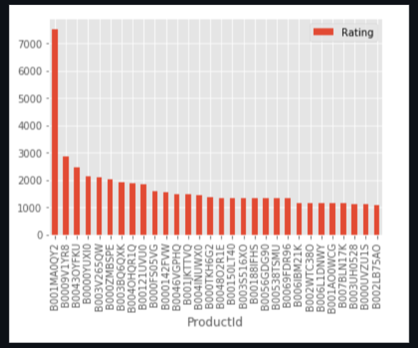

Additionally, to better understand the distribution of electric vehicles (EVs) across different cities in India, we have arranged the cities according to their rank in terms of the number of EVs. This ranking allows us to identify the cities with the highest and lowest adoption rates of electric vehicles. We then plotted the data using a graph, which visualizes the number of EVs for each city based on their rank. This graphical representation provides a clear and concise view of the EV adoption trends across different cities, highlighting potential hotspots and areas that may require more attention in our market entry strategy. By examining the data in this manner, we gain valuable insights into the regional variations in EV adoption and can tailor our approach to target specific cities and regions with higher

# Segment Extraction:

# The Ultimate E-commerce Product Recommendation Guide for 2020

# In shaping our E-commerce Recommendation System, market segmentation emerged as a pivotal strategy to deliver personalized user experiences. We carefully analyzed user behavior, demographics, and preferences to categorize them into distinct segments. By considering factors like purchase patterns, age, gender, geographical location, and interests, we identified key user groups. Employing clustering techniques further refined our segmentation, enabling tailored recommendations for similar user behaviors. Our resultant segments included fashion enthusiasts, tech aficionados, home and lifestyle seekers, health and wellness enthusiasts, and book and education enthusiasts. This segmentation approach allows us to offer targeted product suggestions, ensuring user satisfaction, engagement, and improved conversion rates.

# Application Constraints and Business Needs for E-commerce Recommendation System

# In the pursuit of developing an impactful E-commerce Recommendation System, it's crucial to consider both the application constraints and the underlying business needs. These factors shape the system's design, functionality, and overall effectiveness. Here's an overview of the application constraints and business needs that guided our approach:

# Application Constraints:

# Data Privacy and Security: Ensuring the privacy and security of user data is paramount. Strict adherence to data protection regulations and robust encryption protocols must be implemented to safeguard sensitive information.

# Scalability: As the user base grows, the system must seamlessly handle increased data volume and user interactions. Scalable infrastructure and efficient algorithms are essential to prevent performance bottlenecks.

# Real-time Responsiveness: The recommendation system should provide real-time suggestions, requiring efficient data processing and algorithm optimization to deliver timely recommendations to users.

# Data Quality and Completeness: The system's accuracy relies on high-quality and complete data. Efforts must be directed towards data cleaning, handling missing values, and ensuring data consistency.

# Cold Start Problem: Addressing the challenge of providing recommendations for new users without purchase history or ratings is crucial. Effective strategies, such as popularity-based recommendations, are required to tackle this constraint.

# Business Needs:

# Enhanced User Experience: The primary objective of the recommendation system is to enhance user experience by offering relevant and personalized product suggestions. This drives user engagement, increases time spent on the platform, and fosters brand loyalty.

# Customer Acquisition and Retention: Personalized recommendations attract new customers and encourage existing ones to make repeat purchases. Improved customer acquisition and retention lead to higher revenue generation.

# Increased Conversion Rates: By guiding users towards products aligned with their preferences, the system improves conversion rates, transforming browsing users into active buyers.

# Competitive Edge: A sophisticated recommendation system sets the business apart from competitors, offering a unique and tailored shopping experience that resonates with users.

# Data-Driven Insights: The recommendation system generates valuable insights into user behaviors, preferences, and trends. This data can inform business decisions, product offerings, and marketing strategies.

# Upselling and Cross-selling: The system's recommendations can strategically promote related or complementary products, driving higher average order values through upselling and cross-selling.

# Operational Efficiency: Automated recommendations streamline the user journey, reducing the time and effort required for users to find products they are interested in, thus enhancing operational efficiency.

# Balancing these application constraints and business needs ensures that the E-commerce Recommendation System is not only technically sound but also aligns seamlessly with the organization's goals, contributing to sustained growth, improved user satisfaction, and a competitive advantage in the market.

# conclusion

# In conclusion, our E-commerce Recommendation System stands as a testament to the harmonious fusion of technology and business imperatives. By comprehensively addressing application constraints such as data privacy, scalability, and real-time responsiveness, we have established a robust foundation for seamless and secure user experiences. Simultaneously, our unwavering commitment to fulfilling business needs, from enhancing user satisfaction and driving customer acquisition to optimizing conversion rates and extracting valuable insights, underscores our system's strategic relevance. Through the careful interplay of these elements, our recommendation system not only empowers users with personalized product suggestions but also positions the business for sustained growth, competitive advantage, and enduring customer loyalty. As we navigate the dynamic landscape of e-commerce, this system exemplifies our dedication to shaping a future where technology and business objectives coalesce for mutual success.

.